Name Date
Writing Chemical Equations
A word equation is one way of representing a chemical reaction: it tells you what reacts and what is produced. Word equations are an efficient way to describe chemical changes, to help chemists recognize patterns, and to predict the products of a chemical reaction.

What are products and reactants?
- Reactants:
  - Look for the substances that come before words like “combine”, “react together”, “react”
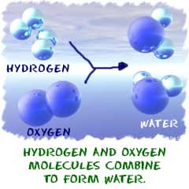
- Products:
  - Look for the substances that come after words like “form”, “create”, or “make”
  - Example: The reaction to the right can be written as
hydrogen + oxygen → water
H₂ + O₂ → H₂O
- The reactants are
- The products are

Writing Word Equations
Word equations are written in a particular format. The left side of a word equation lists the names of all the REACTANTS, and the right side lists the names of all the products. An arrow points from the reactants to the products: all the reactants → all the products
The reactants, as well as the products, are separated by a plus sign (+):

reactant 1+ reactant 2 → product 1 + product 2
Example:
Iron metal is placed in a flask containing oxygen gas (O₂). Orange and yellow sparks are visible and there is smoke inside the flask. At the end of the reaction, iron (III) oxide has been created.

- What is the evidence of a chemical reaction?
- Reactant(s)
- Product(s)
- Word equation
You try:
Sodium bicarbonate, reacts with acetic acid. When they are mixed, there is vigorous fizzing and white bubbles are visible. The reaction creates sodium acetate, water and carbon dioxide.

- What is the evidence of a chemical reaction?
- Reactant(s)
- Product(s)
- Word equation

