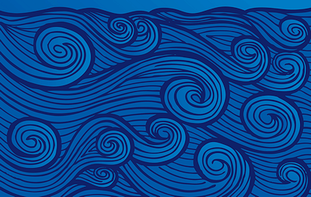

*Can I compare and contrast different types of waves and how they travel?*

1. In your own words or pictures, describe what a wave is:
2. List any examples of different types of waves:

Give 2 examples of types of energy that travel in waves:

(1)

(2)

*Other notes from Bill:*

**Definition of a wave**: any

____________________ that transmits ______________ through ______________ or __________________________

* As they travel, they do ___________ on everything in their path

**What is a medium?**

**____________________________________________________________________________________________________________**

* Can be a _______________, ________________, or __________

# Bill Nye & Waves

**Waves**

Surface Waves (ex: Water waves)

**Observations/Description Picture _**

Longitudinal Waves

**Observations/Description Picture Examples**

Mechanical Waves

**Description:**

**Examples:**

Transverse Waves

**Observations/Description Picture Examples**

**Cell Phone in Bell Jar Demo**

1. What happened when the phone was called BEFORE the air was removed from the jar?
2. AFTER the air was removed?
3. Explain WHY the result was different in #1 and #2.

____________________________________________________________________________________________________________________________________________________________________________________________________________________

**Electromagnetic Waves**

**Description:**

**Examples:**