**Waves Properties: Waves on a String**

First Activity: Amplitude

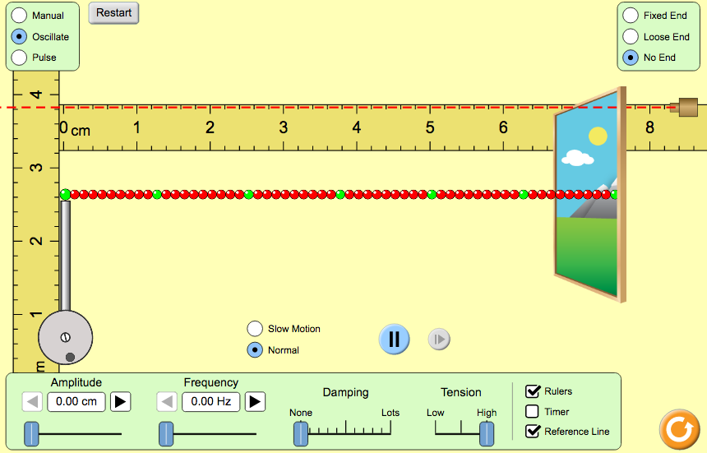Click on the [Wave On A String Link](http://phet.colorado.edu/sims/html/wave-on-a-string/latest/wave-on-a-string_en.html). (HTML5)

1. Set the top controls to **Oscillate** and **No End**.
2. On the bottom menu:
3. Set amplitude, frequency and damping to 0
4. Set tension to high
5. Check the rulers and reference line boxes
6. Record your observations of the string with the initial settings.
7. Set the both the amplitude to 1.0 cm and the frequency to 1.0 Hz. What happens to the string?
8. Set the frequency to 1.5 Hz and adjust the amplitude to several different settings. What happens to the string as you adjust the amplitude? Record your observations.

1. Based on your observations, **define the amplitude of a wave:**

Second Activity: Wavelength and Amplitude

* Set your controls to  and .
* Select Slow Motion 
* Set **amplitude at 0.50 cm** and **frequency at 1.00 Hz**.
* Use the pause button to stop the wave for easier measurement.

1. Move the horizontal ruler to measure the wavelength. Remember: Crest-to-Crest or Trough-to-Trough, such as in the image below. **Each tiny mark on the ruler equates to 0.2 cm**

**Wavelength #1 = _________ cm**

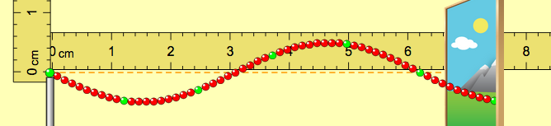

1. Double the **amplitude so it is now at 1.00 cm**, but **keep the frequency at 1.00 Hz**.
2. Restart the wave. Play the oscillation, and then pause it.
3. Move the horizontal ruler to measure the wavelength. **Wavelength #2 = _____cm**
4. How does the wavelength #1 compare to wavelength #2?

1. Did changing the amplitude affect the wavelength?

Third Activity: Wavelength and Frequency

* + Set your controls to  and  and 
  + Keep **amplitude at 1.00 cm** and change the **frequency to 1.50 Hz**.
  + Use the pause button to stop the wave for easier measurement.

1. Move the horizontal ruler to measure the wavelength. **Wavelength #3 = _____cm**
2. Set the frequency so it is now at 2.00 Hz, but keep the amplitude at 1.00 cm.
3. Restart the wave. Play the oscillation, then pause it. Move the horizontal ruler to measure the wavelength.

**Wavelength #4 = _____cm**

1. Set the frequency so it is now at 3.00 Hz. Keep the amplitude at 1.00 cm.
2. Restart the wave. Play the oscillation, then pause it. Move the horizontal ruler to measure the wavelength.

**Wavelength #5 = _____cm**

1. Summarize your data in the chart below. In addition, calculate the speed of each wave, which is equal to the wavelength **(in meters!)** times the frequency.

|  |  |  |  |
| --- | --- | --- | --- |
| Wavelength # | FREQUENCY | WAVELENGTH **(m)** | SPEED OF WAVE **(m/s)** |
| #1 | 1.00 Hz |  |  |
| #2 | 1.00 Hz |  |  |
| #3 | 1.50 Hz |  |  |
| #4 | 2.00 Hz |  |  |
| #5 | 3.00 Hz |  |  |

1. Why did the summary chart not include any information about the amplitude? ______________________

1. Did changing the frequency affect the wavelength?
2. As the frequency increased, what happened to the wavelength?

1. What happens to the wavelength of a wave if the frequency is doubled?
2. What happens to the wavelength of a wave if the frequency is tripled?
3. How did the speed of the waves compare to one another? Can you guess why this was the case? Explain.