Name Date Period

Signs of a Chemical Reaction Lab

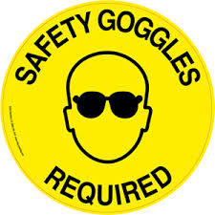
Purpose:
- Describe signs that indicate there was a chemical reaction.
- Identify products and reactants in a chemical reaction.

You will observe 3 different chemical reactions and make careful observations about each. Through this process, you will be able to describe signs that indicate that a chemical reaction has occurred.

Reaction 1: Demonstration
What was mixed?
What happens when they are mixed?

Reaction 2: KI and Pb(NO₃)₂
- Fill a test tube half way with potassium iodide solution, KI. Record observations about the appearance of the KI solution.
- To the test tube, add 2 drops of lead (II) nitrate solution, Pb(NO₃)₂. Make sure you pay attention to what the lead (II) nitrate looks like before you add it to the KI.
- Record any observations you make when the two solutions are mixed. Let your test tube sit until you finish the next part of the lab.

Observations:
Potassium iodide
Lead (II) nitrate
What happens when they are mixed?
Draw and describe the contents of the test tube after it has been sitting for awhile

Clean-Up: Pour the contents of the test tube from Reaction 2 into the beaker labeled “WASTE”. Clean out the test tube with soap and water using a test tube brush.
Reaction 3: NaHCO₃ and CaCl₂ and BTB
- Add one scoop of sodium bicarbonate (baking soda) to your plastic bag and record your observations about what it looks like.
- Add one scoop of calcium chloride, CaCl₂, to your plastic bag and record your observations about what it looks like.
- Mix the sodium bicarbonate and calcium chloride in your Ziploc bag.
- To a new small test tube, add universal indicator solution until it is about ¾ of the way full. Record observations about the appearance and properties of the universal indicator.
- STOP BEFORE GOING ON TO THE NEXT STEP AND HAVE A TEACHER COME CHECK EVERYTHING AND HELP YOU WITH THE NEXT STEP
- CAREFULLY place the small test tube into the baggie, being careful NOT to tip it over or allow it to mix with the sodium bicarbonate or calcium chloride. Squeeze excess air out of the bag and carefully seal it.
- Tip over the small test tube INSIDE the baggie and allow the 3 compounds to mix.
- Allow everyone in your group to feel the bag and record any observations you make as the reaction progresses. Be careful not to squeeze the bag!

Observations:
Sodium bicarbonate
Calcium chloride
Universal indicator
What happens when they are mixed?
Why do you think that we carried out this reaction in a sealed plastic baggie?

Clean-Up: Pour the contents of your plastic bag down the drain, being sure to rinse with plenty of water. Clean out the test tube with soap and water using a test tube brush. Throw the baggie into the trash. Wipe down your table and return any items to their original location. Wash your hands and return your apron and goggles.

Discussion Questions
- List at least 4 signs that a chemical reaction occurred.

- When you observe bubbles forming in a chemical reaction, what does that indicate?

- Why did we need to make sure to squeeze excess air out of the plastic baggie before zipping and up and mixing the contents?

- Reactants are the chemicals that are present before a reaction begins… the things you start with. Identify the reactants for each of the 3 reactions.

  - The reactants in Reaction 2 are
  - The reactants in Reaction 3 are

Part A: What are products and reactants?
- Reactants:
  - Look for the substances that come before words liks “combine”, “react together”, “react”
- Products:
  - Look for the substances that come after wods like “form”, “create”, or “make”
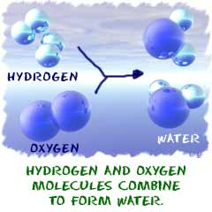
  - Example: The reaction to the right can be written as
hydrogen + oxygen → water
H₂ + O₂ → H₂O
- The reactants are
- The products are

