Name:______________________________________ Period:_____
Scientific Variables
Identify the independent and dependent variable in each scenario. For controlled variables, list at least 3 things that should be kept constant, even if they are not mentioned in the scenario.
Scenario |  | Independent | Dependent | Constants (Controlled)
One chicken is injected with a growth hormone while another chicken is not injected. Both chickens are weighed after a year. | 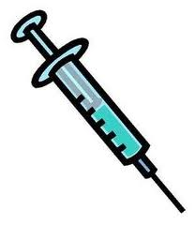 | Use of growth hormone | Weight of chickens | - same type of chickens  - chickens eat same food  - chickens live in same environment
A bug repellant is sprayed on one arm the other arm is not sprayed. The number of bug bites on each arm is recorded after 2 hours. | 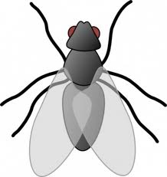
Garfield sleeps 9 hours the night before his science exam. His twin sister has the same exam and sleeps 6 hours the night before the test. Afterwards, they compare their scores on the test. | 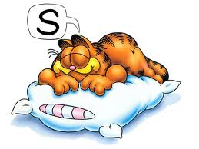
Group A exercises for a month. Group B does not exercise. Throughout the month, they record their weight. | 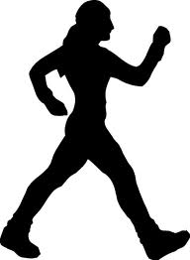
One math class studies for an assessment while the math class next door does not. The scores of the two classes are compared.
One plant is given sunlight every day. Another plant is kept in a dark closet. Over the course of 3 weeks, we measure the height of the plant. | 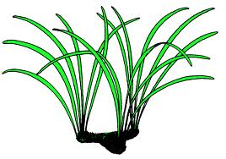
One plant is given fertilizer A. Another plant is not given any fertilizer. Over 3 weeks, we record how green each plant looks.

Scientific Variables KEY
Identify the independent and dependent variable in each scenario.
Scenario |  | Independent | Dependent
One chicken is injected with a growth hormone while another chicken is not injected. Both chickens are weighed after a year. |  | Growth hormone | Weight of chickens
A bug repellant is sprayed on one arm the other arm is not sprayed. The number of bug bites is recorded after 2 hours. |  | Bug repellant | Number of bug bites
Javier sleeps 9 hours the night before his science exam. His twin sister has the same exam and sleeps 6 hours the night before the test. Afterwards, they compare their scores. |  | Hours of sleep | Exam scores
Group A exercises for a month. Group B does not exercise. They measure the amount of weight they gained. |  | Exercise | Weight
One math class studies for an assessment while the math class next door does not. The scores of the two classes are compared. |  | Studying | Test score
One plant is given sunlight every day. Another plant is not given any sunlight. After 3 weeks, we measure how tall the plant is. |  | Sunlight | Height of plant
One plant is given sunlight for 12 hours a day. Another plant is not given any sunlight. After 3 weeks, we compare how green each plant looks. |  | Sunlight | Color/shade of green

