Electromagnetic Waves

Background Information
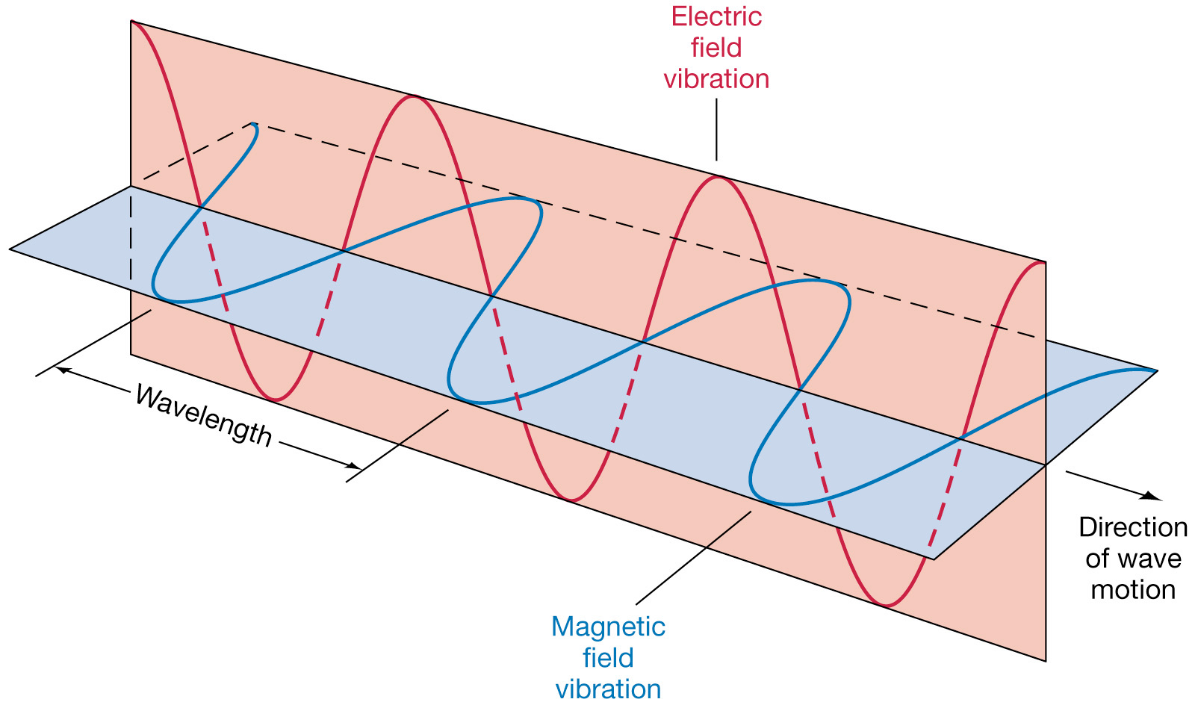
Electromagnetic waves are made of vibrating fields and fields, which are perpendicular to each other in an EM wave
Surround every charged object Surround every magnet

- Produced by vibrations of . The vibrating
creates a .
- The transfer of energy as electromagnetic (EM) waves is called .
- The entire range of EM waves is called the .

The Electromagnetic Spectrum
Type of Wave | Wavelength | Uses/Examples | Other Notes
Wavelength ______
Frequency ______
Radio waves
Microwaves
Infrared
Visible
Ultraviolet
X-Rays
Gamma Rays
Wavelength ______
Frequency ______
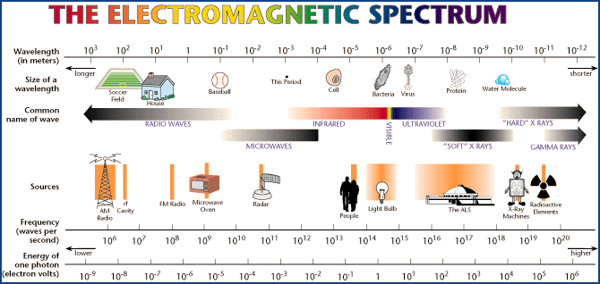
Summary:
____________________________________________________________________________________
____________________________________________________________________________________
____________________________________________________________________________________
____________________________________________________________________________________
____________________________________________________________________________________

